Business Name
Contact Name
Business Address
Post Code
Home Phone |  |  | Mobile
Email
Facebook
Instagram
Twitter
WhatsApp
Product Description
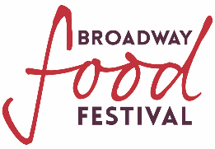
Do you supply the village? | Yes/No
If Yes who do you supply

Is your insurance renewal date before September 15th 2024? If Yes please state here. | Yes/No
Local authority you are registered with.

Will you be cooking on the stall? | Yes/No
Will you be selling temperature-controlled food on the stall? | Yes/No

Do you perceive any Health and Safety risks?

Specific access requirements

Number of 3m indoor spaces required?
Number of 3m outdoor pitches required?

.$%$( &"  " "
$/+) $
.$%$( &"  " "
$/+) $
.$%$( &"  " "
$/+) $
N.B. If you are bringing a trailer the charge will be for the full length of the trailer including towbar. This charge will be £30 for each additional metre.

Amount of electricity supply required? (Please circle)
16A | 1 | 2
32A | 1 | 2

Please detail the equipment you will be using.

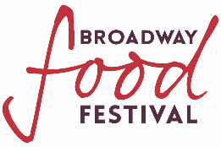

Agreement
The information in this application is accurate and true to the best of my knowledge. I have read and understood the Broadway Food Festival 2024 Terms and Conditions and agree to be bound by them. Our Terms and Conditions are located on our website.

Yes/No

Your name

Please email this along with your

- Current public liability insurance certificate,
- Completed Risk Assessment form,
- Picture of trailer.

To

broadwayfoodfestival@gmail.com

